107 Things to Do When You’re Bored
- Do a puzzle (the more pieces, the better). This could also be a Rubik’s Cube, word search, or crossword puzzle.
- Start a journal or diary. It will make an interesting read in about ten years!
- If you play an instrument, practice. If not, maybe it would be a good time to learn!
- With your parents’ permission, call your friends. A long conversation with a good friend can go a long way!
- Write some poetry.
- Learn a foreign language.
- Read that book that has been sitting in your room unread.
- Meditate. Sit cross-legged for twenty minutes and focus on your breathing.
- Give yourself or someone in your family a makeover.
- Look through old family photos.
- Try a new recipe.
- Try a new craft.
- Write letters to friends and family and mail them.
- Learn calligraphy.
- Play a board game with your family
- Put on a play. Write your script. Create scenery. Make costumes.
- Organize your room or another space in your house.
- Go through your closet, dresser, and toy box and see if anything can be donated to charity.
- Clean out your desk.
- Have a tea party. Create some treats to eat and dress up fancy.
- Plan a complete dinner menu with your family. Cook it together. Maybe make it a theme party.
- Watch old (age-appropriate) movies.
- Try a new workout routine.
- Draw a self-portrait while looking in the mirror.
- Paint a picture.
- Take a bubble bath.
- Create a new kind of drink with fruit juice and/or soda.
- Color in a coloring book.
- Create personal goals for yourself. What would you like to accomplish by the end of the school year? By the end of middle school? High school? College? Etc.
- Write a short story or start a novel.
- Create an indoor campout with sleeping bags and sheets laid across furniture.
- Have a movie marathon. Anyone for Harry Potter?
- Fix something you’ve been meaning to fix.
- Do some origami.
- Interview your grandparents or another adult in your life over the phone. What can you create with the information?
- Make a photo collection for someone special.
- Make a list of all of the movies you’ve seen. Now rank them from the one you like the best to the one you like the least. Compare your list with a friend over the phone.
- Make a list of all of the things that you are grateful for.
- Try a new food you’ve never tried.
- Have a taste-testing party with your family. Have people put on a blindfold and taste food to try to guess what each one is.
- Plan some ways that you could save money.
- Cook an old family recipe.
- Make milkshakes or have an ice cream sundae party with your family.
- Make cards to send to sick people or to health care workers in the hospital. Mail them to the hospital.
- Pass the story. With your family, start a story. Each person takes turns adding a few more lines to the story.
- Have a read-aloud with your family using a chapter book.
- Have a Scrabble, Yatzee, or Pictionary tournament.
- Have a contest to see who can make the best recipe using the same limited number of ingredients.
- Have an indoor scavenger hunt.
- Read a book that was made into a movie and then watch the movie. Discuss the similarities and differences with your family.
- Make a list of all of the places you’d like to visit.
- Create a new comic strip.
- Rearrange your room.
- Learn how to shuffle cards.
- Teach your pet a new trick.
- Memorize the periodic table.
- Learn a new style of dance.
- Break out those Legos and see what you can create.
- Learn all of the words to one of your favorite songs.
- Try doing things with your non-dominant hand for one day.
- Practice your typing skills.
- Do some yoga.
- Learn to speak in Pig Latin.
- Plant some plants to brighten up your home.
- Write a song.
- Try to move in super slow motion. How long can you last?
- Take a nap.
- Play tic-tac-toe with someone.
- Go for a walk or bike ride (safely).
- Write a note to someone, letting them know how much they mean to you.
- Measure the area and perimeter and area of each room in your home.
- Graph the birds that visit your yard or fly past your window.
- Be completely silent for 60 minutes and then write about the experience.
- Build a “fable fort.” Create stories as a family.
- Learn Morse Code. Use it to communicate with your family by knocking on walls.
- Alphabetize the spices in your kitchen.
- Stay up late and stargaze.
- Call a grandparent or older relative. Ask them to teach you the words to their favorite childhood song.
- Using household materials, build a working rain gauge, barometer, and wind vane. Keep track of your weather data.
- Determine and chart the times that different liquids require to turn solid in the freezer.
- Design and build puppets that perform a show.
- Construct a family tree.
- Learn ten new big words. Write them in marker on your bathroom mirror (with permission).
- Draw a map of your home.
- Sit silently for 15 minutes while you write down every sound you hear. When you are done, classify the sounds (high/low pitch, high/low volume, manmade/naturally occurring, etc.).
- Create a Venn Diagram that compares and contrasts two people in your family, your neighborhood, or another group that you belong to.
- Learn, practice, and perform a magic trick.
- Learn, practice, and tell three new jokes.
- Use household materials to make and play stringed, percussion, and wind instruments.
- Collect leaves from ten different (non-harmful) plants. Sort them by size, color, and texture.
- Put your favorite book, toy, and keepsake on a small table in sunlight. Draw or paint a full color still life.
- Find, pick, and dissect a flower.
- If you have stairs, walk up and count them. Walk down and count by twos. Walk up and count by threes. Continue by tens.
- Determine the volumes of ten containers, then display them in order in your house.
- Write a poem on your sidewalk using chalk.
- Classify twenty everyday objects by shape, size, color, height, mass, and material.
- Measure the length of your bed using five different nonstandard units.
- Call a person who speaks a language you do not. Ask them to teach you five common words or phrases.
- Create and use a secret code.
- Using one type of paper (constant), build three different paper airplanes (independent variable) and test to see how far they fly (dependent variable).
- Set a clock three hours and seven minutes ahead. Whenever someone needs to know the time, help them figure it out by subtracting.
- Write down every adjective you say for one full day.
- Design a map of every state ever visited by people in your family.
- Write or tell a story titled "What if humans had to leave the Earth and no one remembered to turn off the last robot?"
- Find ten rocks smaller than a dime.
- Using paper, tape, and string, design, build, and test a device that warns you when someone opens the kitchen cabinet.
- Imagine, create, and fly a full-size flag that tells the world about you.

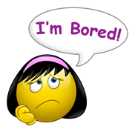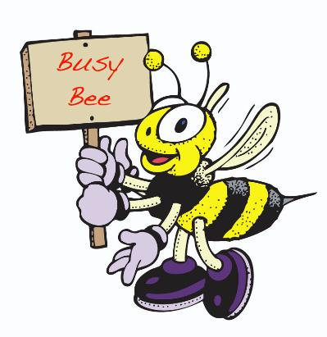
This Photo by Unknown Author is licensed under CC BY-ND

