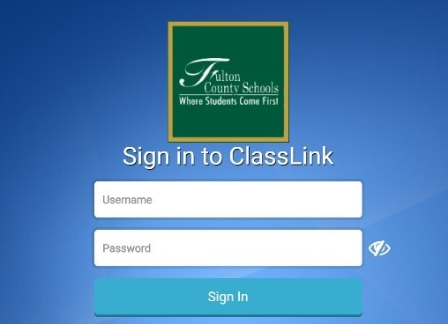1) Log into Classlink

2) Click on your Microsoft Office 365
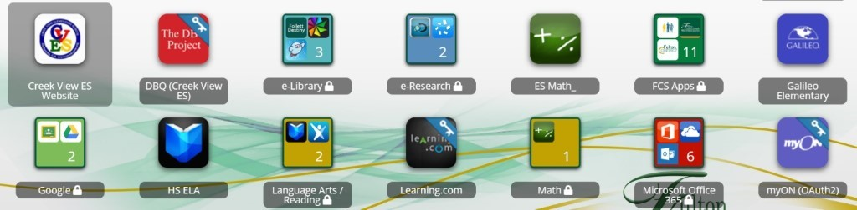

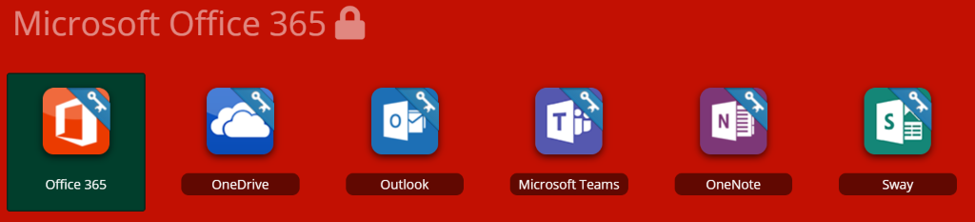3) Click on “Microsoft Teams”

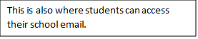

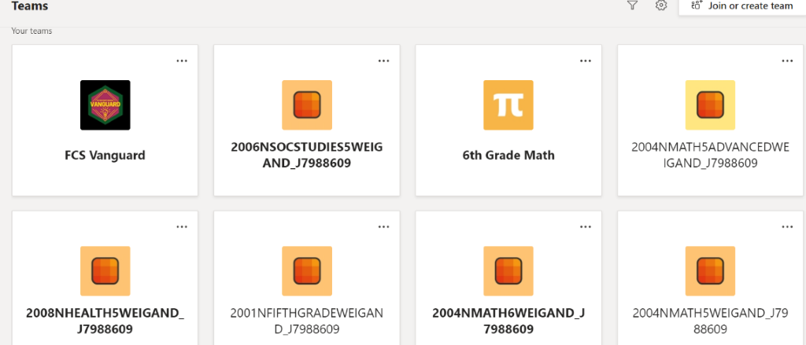4) Click on the class you chose to work with at that time.

